Oliver Collins-Cope

2102775@rutc.ac.uk

Learning Aim B & C

Develop a design for an Internet of Things system or device to solve a problem & Carry out the prototyping of an integrated Internet of Things system or device to solve a problem

Unit 19 Internet of Things

Assignment 2

Contents

Introduction 2

Problem definition statement 2

Purpose requirements 3

Diagrammatic illustrations and written annotations 3

Communication infrastructure 3

Feedback 7

Justifying alternative ideas and preferred solution 7

Improvements on design 7

Final design review 7

Creating the system 7

Optimisation 7

Evaluation 7

# Introduction

For this assignment I will be covering the benefits of a healthcare alarm that can aid in detecting when something happens to homeowners, such as someone breaking in. The advantages and disadvantages are vast for this, and some of the advantages include things like early detection for breaches of home, and peace of mind for household/family members themselves. The only disadvantages include the production costs and maintenance cost. This means that once the initial cost is covered and the IoT device is maintained, this device only benefits the homeowners.

# Problem definition statement

The problem in this scenario is the issue of having an alarm that can be used to detect whenever a door or someone has set off a motion alarm that can then alert the homeowner covertly, such as through a mobile notification. The intended audience of this would be the any homeowners looking to secure their property from malicious thieves.

The constraints of this project vary depending on the perspective you take, such as a lack of technical ability not knowing how to utilise these different aspects of the technology, like the motion sensor or camera. Another example of a constraint of this would be the cost to create and make all of these pieces of technology, or to purchase all of these components.

The benefits of using a motion detection system means that it will create a safer environment within the home for the homeowner, and it creates a self-sustaining alarm system that will constantly notify the homeowner if something happens within the home, like unauthorised access.

The nature of user interactivity here will be based in mobile applications and access to alerts/camera through this application. Due to this access, through the mobile application, the user will be able to gain access to their home and view it through the camera, while also being aware of any changes that might happen through the motion detection.

Some accessibility considerations of this application might be audible alerts that describe what can be seen on the camera, such as “a hooded figure moving across the room”, or audio alerts describing the time that the alert was made. Additionally, another accessibility feature that could help might be text-based options for the video feed, i.e., describing what is going on through the use of AI, or a microphone in the camera.

# Purpose requirements

The purpose of the IoT system is to address the alarm system. The system should be able of detecting any movement within a room using a camera connected to a Raspberry Pi or a similar microcomputer. Once movement is detected, the system must send an alert to a mobile device.

Several parts are needed to be able to complete this. Firstly, the system should provide a detection ability. This can be achieved by using cameras capable of differentiating between different types of movement, such as distinguishing a person from a pet, to prevent false alarms.

Next, the system should ensure real-time alert notifications. This means there is a need for consistent connectivity. Continuing, the system should be user-friendly and offer easy customisation of alarm settings, including setting up the app to receive alerts. The system should also provide an interface for system status monitoring and alarm management.

Lastly, the system should be designed considering scalability. As houses expand, the system should allow for an easy integration of additional cameras and motion sensors and be adaptable to new technologies and standards in the IoT ecosystem.

# Diagrammatic illustrations and written annotations

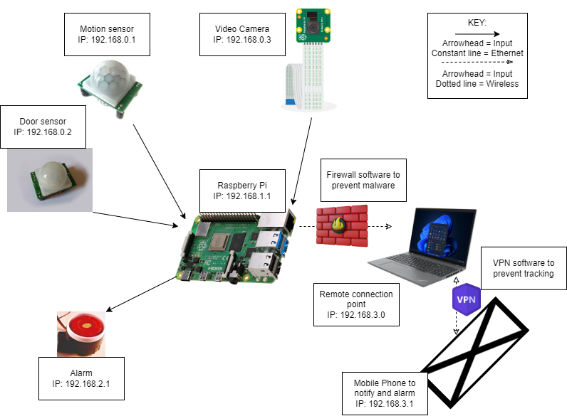

The design of the IoT system involves an optimised functional system. The system's central element is a Raspberry Pi, acting as the microcontroller, interfacing with all components.

The system incorporates a camera, providing the necessary input. Upon sensing motion, these motion detector sends a signal to the Raspberry Pi. The sensor's sensitivity parameters can be changed to prevent false alarms.

The Raspberry Pi, once triggered, sends a notification. This alert is sent to a mobile device through Wi-Fi. Wi-Fi has been selected as the method of sending the notification due to its availability and ease of integration with the Raspberry Pi. It provides the system with internet connectivity, allowing the sending of notifications.

This system design reflects a balance of functionality, and user-friendly operations. The choice of components aligns with the requirement to use off-the-shelf hardware, simplifying the assembly process. The visual diagram accompanying this details the connections and communication flow within this IoT system.

# Communication infrastructure

## Understanding Sensors in the IoT Systems

A key component of an IoT system is its sensors. These devices are tasked with the important role of collecting data from the surrounding environment. These sensors make sure to capture all the data, and in this instance that means video feed and motion detection. Following data collection, raw data is digitised and made understandable. This conversion facilitates real-time data interpretation and interaction by the system, therefore making it efficient.

## Wired and Wireless Communications in IoT

IoT systems heavily rely on both wired and wireless communication channels. Wired connections like Ethernet provide high-speed data capabilities, which are crucial for specific applications within IoT. On the other hand, wireless technologies including Wi-Fi and Bluetooth Low Energy (BLE), introduce flexibility in setup and deployment. In addition, unique identification systems using RFID and QR codes further enhance the performance of IoT applications.

## Actuators in IoT Systems

The actions in an IoT system are primarily driven by actuators, effectively serving as the "muscles" of the system. Based on instructions received from the control system, actuators initiate physical movements or changes by controlling various devices, motors, and servos. This way, the digital data and commands in the system are transformed into concrete actions, sealing the loop within the IoT system.

## Device Domain in IoT Systems

The device domain within an IoT system is what allows communication between its components within a given scope like a Personal Area Network (PAN). Essentially, the device domain is responsible for creating an interconnection between multiple devices, such as sensors and actuators, enabling data sharing environment.

## Network Domain in IoT

Linking Machine-to-Machine (M2M) gateways with M2M applications is the primary role of the network domain within an IoT system. It uses Wide Area Networks (WAN) or Wireless Local Area Networks (WLAN) to ensure connectivity and data sharing between system components, no matter their geographic locations.

## Application Domain in IoT Systems

The application domain forms the intermediary layer within an IoT system. This is where data captured by sensors gets processed and is made available to business logic layers. The application domain is tasked with making sense of the data and providing actionable insights that deliver value to the end-user or customer. The application domain, in essence, turns raw data into comprehensible and useful information for informed decision-making and automatic responses.

# Feedback

This is the feedback I received for the design that I showed to others:

This questions included a screenshot of the design and shows how it is highly evaluated the design is just based on the initial idea.

This response further encourages the idea that people who responded thought that the design was high quality, as it “includes most things”, “explains everything in detail”, and more.

This question ensures that the system is secured from potential vulnerabilities, meaning that the design is safe to implement.

This shows potential improvements for the design that I will implement below, the idea of adding in an additional firewall and a door/application is definitely an attractive idea.

This was another question aimed at improving the system and shows options that I could take to make sure that the system works well.

There are both actuators and sensors in this, however I will ensure that there is a door and mentions of an application for the notification.

# Justifying alternative ideas and preferred solution

The primary focus of our IoT system is to address the alarm system requirements. The system must be able to detect any movement within a room, with the assistance of a camera interfaced with a Raspberry Pi or a similar microcomputer. Upon sensing movement, it's important for the system to deliver an alert to a mobile device promptly.

There are several components needed to realise this solution. The foremost requirement is for the system to possess a detection capability. By utilising cameras, capable of differentiating between different types of movement - such as a human from a pet - the system can effectively prevent false alarms.

Moreover, ensuring real-time alert notifications is a key requirement. This means a system with constant connectivity. Furthermore, the system should be simple, offering straightforward customisation of alarm settings, including the configuration of the app to receive alerts. A system status monitoring and alarm management interface should be provided, enhancing the user experience.

Beyond the current implementation, some improvements could be considered. Firstly, introducing a door would enhance the designs security and accuracy capabilities.

Additionally, in the interest of securing data integrity, a firewall between the camera and the Raspberry Pi should be installed. This digital firewall would monitor and control the network traffic, securing the system from potential cybersecurity threats.

Lastly, for a better user experience, the implementation of an application for phone notifications should be included. An app could provide real-time updates, user-friendly customisation of alarm settings, a clear interface for system status monitoring, and effective alarm management.

In conclusion, the design of the system should consider scalability, facilitating easy integration of additional cameras and motion sensors as the house expands. It's also essential for the system to remain adaptable to new technologies and standards in the ever-evolving IoT ecosystem.

# Improvements on design

Following the previous sections, to improve the *design*, I will be adding a door, a new firewall, and mentions of an application on the design. This can be seen below.



Door

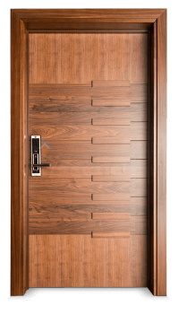

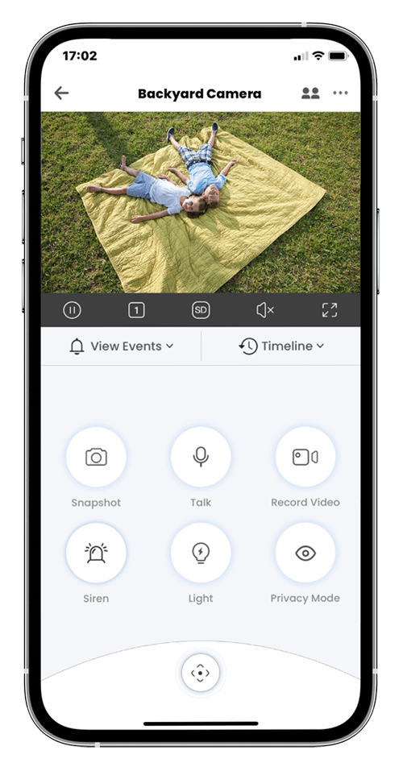

Camera application

# Final design review

At the heart of our IoT system is the Raspberry Pi, a hub that efficiently manages multiple connections. Five key connections are in the design, with a mix of both incoming and outgoing connections that ensure the system's functionality.

Firstly, incoming connections delivering data to the Raspberry Pi include a door sensor, a motion sensor, and a video camera. Each of these components contributes to the system's capacity to accurately detect intrusions. The door sensor and motion sensor provide discrete, targeted detection capabilities, whereas the video camera gives a view of the monitored space.

Importantly, the connection from the video camera to the Raspberry Pi is secured by a firewall. This barrier plays a significant role in the system by monitoring and controlling data traffic, ensuring the protection of data, and maintaining the overall security of the system.

On the other end, outgoing connections from the Raspberry Pi include an alarm and a device capable of sending alerts to a mobile app. The alarm serves to notify the local environment of a potential intrusion, while the mobile app alerts provide the user with immediate updates, regardless of their location.

Finally, an important element of our design is the connection representing the door monitored by the door sensor. This inclusion shows the focus on securing key entry points, as well as making sure that our system can effectively monitor and alert users of any unusual door activity.

This design reviews a system that effectively includes various IoT technologies to provide a, secure, and user-friendly home security solution. It has been structured for ease of use and adaptability, with the Raspberry Pi's at its core. The design also acknowledges the need for system security, particularly through the inclusion of the firewall. Ultimately, this design aims to provide a reliable and secure IoT-based alarm system.

# Creating the system

Below you can see the screenshots depicting how the system was created using packet tracer.

This is the initial configuration that will be optimised and improved in the future. It shows how all of the previously mentioned aspects of the system are being used, with a difference of the router being the connection rather than the raspberry pi.

This screenshot shows the process of the first image being set up, including the implementation of the password that was mentioned in the feedback. All of the connected devices had to go through this procedure.

This screenshot shows how all of the devices were connected to the network, and how the mobile device was used to view these features using the internet explorer on the device.

This screenshot shows the networks conditions and statements, where “**If**”the motion detector is on, the WebCam and Alarm turn on, and vice versa for then the motion detector is off.



Finally, these screenshots show how the system is all turned on when the door is locked/unlocked and the motion detector it triggered.

# Optimisation

# Evaluation